Third-Party (ICT) Risk Assessment
End-to-end process, from CIF identification to exit — DORA-aligned
July 2026

Third-Party (ICT) Risk Assessment — End-to-End Process
Purpose. A single, repeatable process for assessing and managing an ICT third-party service provider across its full lifecycle, anchored on the Digital Operational Resilience Act (DORA, Regulation (EU) 2022/2554) and its technical standards. The process is deliberately front-loaded: you decide whether the function is a Critical or Important Function (CIF) first, because that single decision sets how deep everything downstream needs to go.
Scope. Applies to any arrangement where a third party provides ICT services that support the firm’s business operations — new selections, renewals, and material changes. Proportionality applies throughout (DORA Art. 28(1)(b)): the effort is scaled to the criticality and risk of the arrangement.
Companion tool. Each step maps to a tab in the TPRM Assessment Toolkit workbook.
Note on references. Article and standard references below are drawn from EUR-Lex-verified working notes. Confirm the exact wording against the primary text on EUR-Lex before relying on any clause operationally. This document is a practitioner process, not legal advice.

Process at a glance
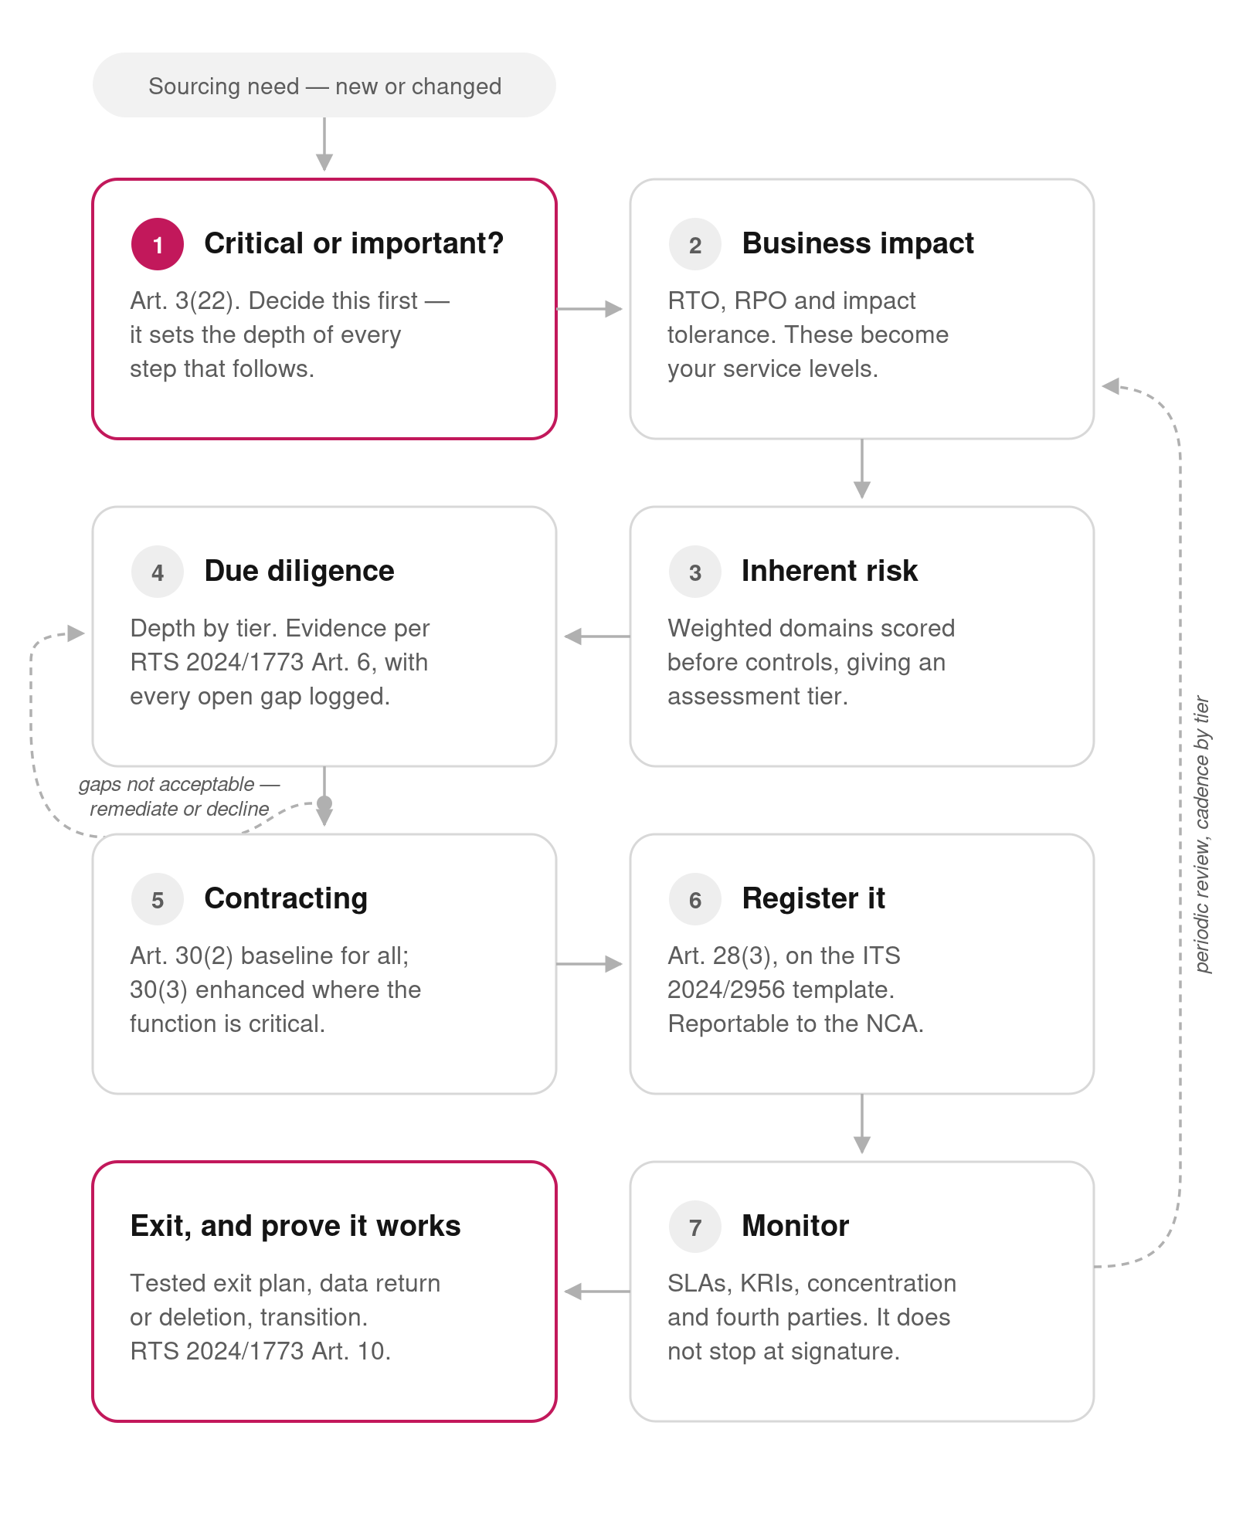
TPRM lifecycle flow

The seven steps

Step 1 — CIF identification (start here)
Before any risk scoring, determine whether the business function the vendor supports is a Critical or Important Function. Under DORA, a CIF is a function whose disruption would materially impair financial performance, the soundness or continuity of services and activities, or the firm’s ability to meet the conditions and obligations of its authorisation. If the answer is yes, the enhanced contractual requirements of Art. 30(3), full due diligence, a tested exit plan, and ongoing monitoring all become mandatory. If no, a proportionate, lighter-touch assessment is sufficient.
Output: a documented CIF / not-CIF decision with the reasoning and evidence. Toolkit: Tab 1.

Step 2 — Business impact analysis (RTO / RPO / impact tolerance)
For a CIF, quantify the consequences of failure and the recovery requirements. Set the Recovery Time Objective (maximum tolerable time to restore the service), the Recovery Point Objective (maximum tolerable data loss), the maximum tolerable downtime, and the board-level impact tolerance for the important business service the function supports. Capture the data classification the vendor will handle and whether personal data is involved. These numbers become the contractual SLA and the continuity and backup obligations later.
Output: RTO, RPO, impact tolerance, data classification, financial impact estimate. Toolkit: Tab 2.

Step 3 — Inherent risk scoring → assessment tier
Score the arrangement across risk domains — data sensitivity, access and connectivity, criticality and substitutability, concentration, jurisdiction, sub-outsourcing, financial viability, and regulatory exposure — before controls. The weighted score, combined with the CIF result, sets the assessment tier:
- Tier 1 — Enhanced: any CIF, or a high inherent score. Full due diligence, all Art. 30(3) clauses, tested exit plan, active monitoring.
- Tier 2 — Standard: medium inherent score, non-CIF. Standard due diligence and the Art. 30(2) baseline clauses.
- Tier 3 — Simplified: low inherent score. Proportionate, light-touch checks.
Output: inherent risk rating and assessment tier. Toolkit: Tab 3.

Step 4 — Due diligence
Run the due-diligence questionnaire at the depth the tier requires. RTS (EU) 2024/1773 Art. 6 sets out the evidence you can rely on: your own audits or assessments, independent audit reports, the vendor’s internal audit, appropriate third-party certifications (for example ISO 27001 or SOC 2 Type II), and other reliable information. Record each answer, the evidence actually seen, and any residual gap with an owner and a remediation date. Gaps that cannot be closed or accepted send the arrangement back for remediation or decline.
Output: completed DDQ, evidence pack, gap log with owners. Toolkit: Tab 4.

Step 5 — Contracting
Translate the assessment into binding clauses. Every ICT contract carries the Art. 30(2) baseline — service description and subcontracting conditions, processing and storage locations, data availability/integrity/confidentiality, data access-recovery-return on exit, SLAs, incident assistance, cooperation with authorities, termination rights, and training participation. Where the service supports a CIF, the Art. 30(3) enhanced set also applies — quantitative SLAs, material-impact notification, tested contingency plans, cooperation with threat-led penetration testing, unrestricted audit and inspection rights for the firm and the regulator, ongoing performance and subcontracting monitoring, and exit strategies with transition periods.
Output: executed contract mapped clause-by-clause to Art. 30. Toolkit: Tab 5.

Step 6 — Register of information
Record the arrangement in the Register of Information (DORA Art. 28(3)), kept current and reportable to the competent authority on request. ITS (EU) 2024/2956 sets the standard templates (Annexes I–IV), including the Annex II service-type taxonomy (S01–S19, e.g. S18 Cloud PaaS, S19 Cloud SaaS) and the function identifier taxonomy. The register is also the input the ESAs use to designate critical ICT third-party providers (CTPPs).
Output: register entry in the ITS template. Toolkit: Tab 6.

Step 7 — Onboarding, monitoring, and exit
Onboard with access provisioning, SLAs, and escalation paths documented. Then monitor continuously and proportionately — performance against SLAs and KRIs, security posture and certification refresh, financial viability, adverse-media and sanctions screening, concentration and fourth-party changes, and incidents. Keep a documented exit plan for each arrangement, periodically reviewed and tested (RTS 2024/1773 Art. 10), covering service interruption, failed delivery, and unexpected termination, with data return and secure deletion, transition assistance, and full access revocation.
Output: monitoring cadence, KRI dashboard, tested exit plan. Toolkit: Tab 7.

RACI — who does what
R = Responsible, A = Accountable, C = Consulted, I = Informed. Roles are indicative; align to your own operating model.
Activity | Business owner | TPRM / 2nd line risk | CISO / Infosec | Procurement | Legal | Internal audit
Step 1 — CIF identification | A/R | C | C | I | C | I
Step 2 — BIA / RTO-RPO | R | C | C | I | I | I
Step 3 — Inherent risk scoring | C | A/R | C | I | I | I
Step 4 — Due diligence | C | R | A/R | C | C | I
Step 5 — Contracting | C | C | C | R | A/R | I
Step 6 — Register of information | I | A/R | C | C | C | I
Step 7 — Monitoring | R | A/R | C | I | I | C
Step 7 — Exit / offboarding | A/R | C | C | C | C | I
Independent assurance over the process | I | I | I | I | I | A/R

Regulatory map (verify on EUR-Lex before use)
Reference | What it governs
DORA — Reg (EU) 2022/2554, Art. 28 | General principles: full responsibility retained, proportionality, ICT third-party risk strategy, register of information (28(3))
DORA Art. 29 | Preliminary assessment of ICT concentration risk before contracting
DORA Art. 30 | Key contractual provisions — 30(2) baseline, 30(3) enhanced for CIFs
DORA Arts. 31–44 | EU-level oversight of critical ICT third-party providers (CTPPs) by the ESAs as Lead Overseers
RTS (EU) 2024/1773 | Detailed content of the policy on contractual arrangements for ICT services supporting CIFs (incl. due diligence Art. 6, exit plan Art. 10)
ITS (EU) 2024/2956 | Standard templates for the Register of Information (Annexes I–IV; 19 service types S01–S19)
RTS (EU) 2025/532 | Elements to assess when subcontracting ICT services supporting CIFs (reported adopted — verify)
Reg (EU) 2024/1502 | Criteria for designating providers as critical (CTPP) (reported adopted — verify)
EBA/GL/2019/02 | Pre-DORA outsourcing guidelines; being replaced by new EBA guidelines on non-ICT third-party risk (consultation 2025, final expected ~2026)

